Experiment No: 7

Title: Develop and simulate ladder diagram for simple on-off applications

Date: 01/12/2021
Name: Shaunak Deshpande
Class: TY IC-C
Roll number: 39
GR Number: 11911180

Q.1) When toggle switch is closed the relay will activate then a green lamp on and when toggle switch opens relay will deactivate the red lamp on Draw relay wiring and relay logic ladder.

Ladder Diagram Initial Condition:
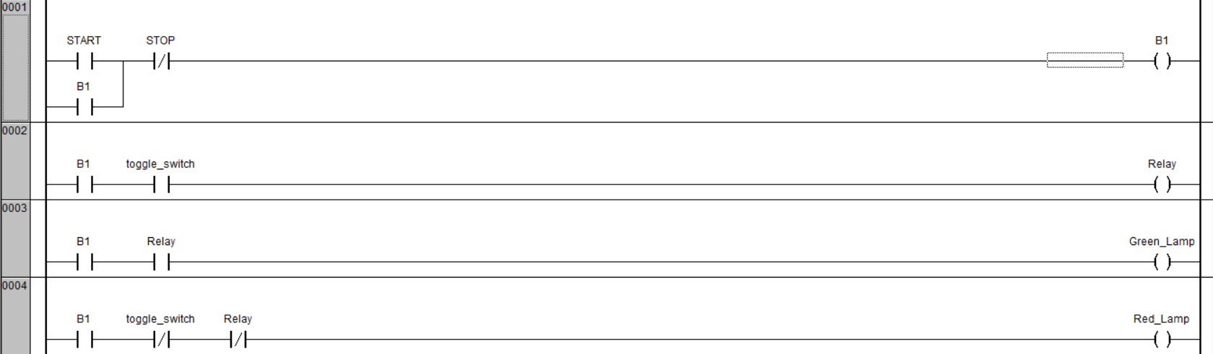

Ladder Diagram Running Condition:

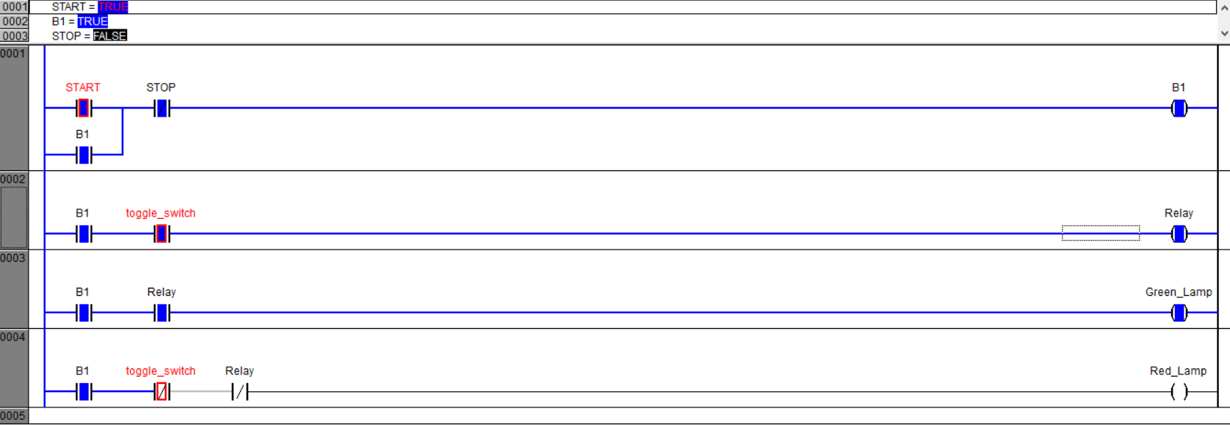

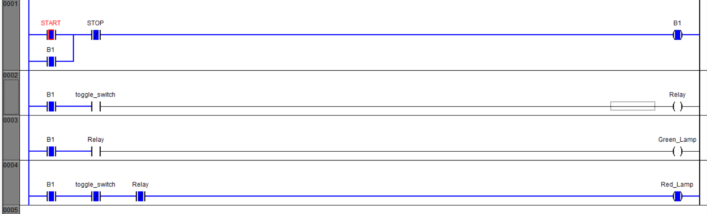

Q.2) Start and Stop pushbutton. They are spring return Draw a PLC diagram of latching of pushbuttons?

Ladder Diagram Initial Condition:
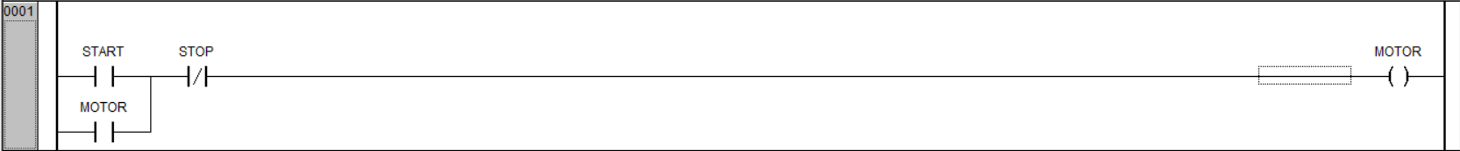

Ladder diagram Running Condition:
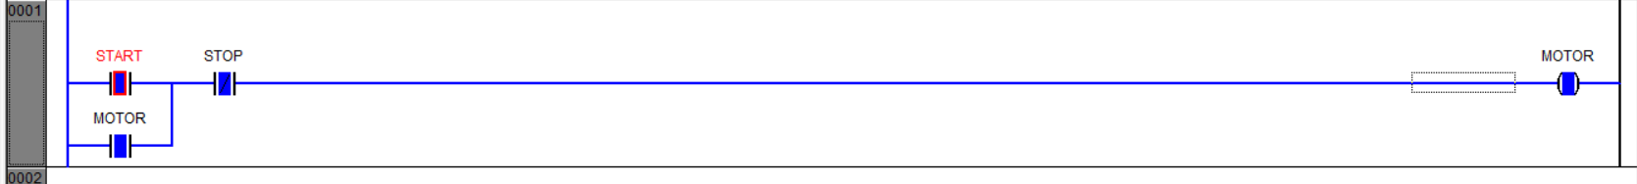

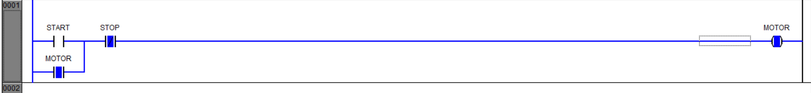
Q.3) The light should be on when either switch A is on (i.e. closed) or switch B is on (closed). Otherwise it should be off.

Ladder Diagram Initial Condition:

Ladder diagram Running Condition:
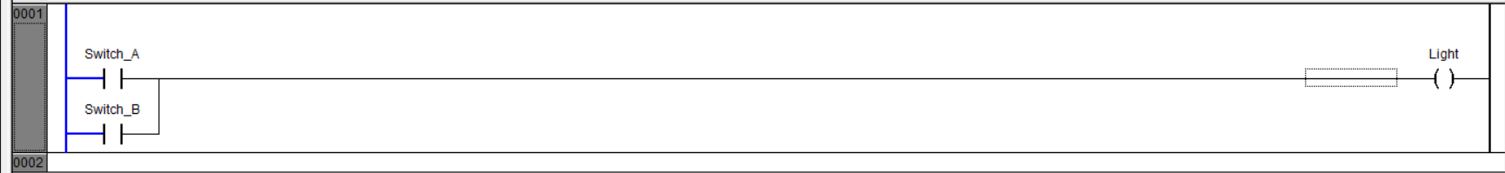
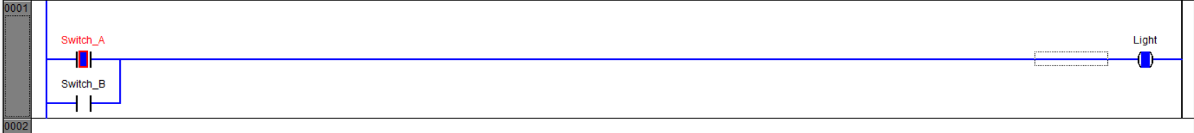

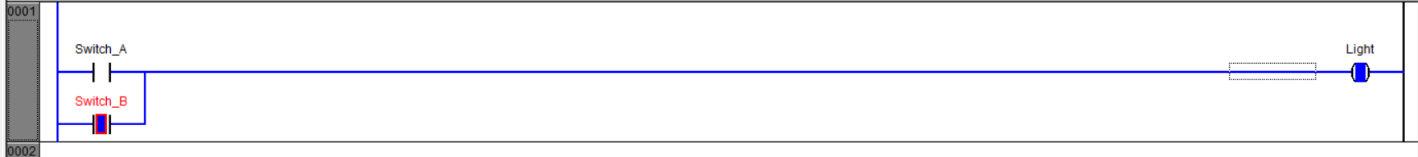

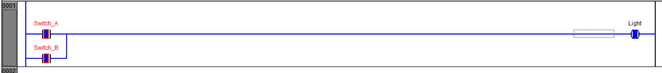

Q.4) The light should be on only when switch A is on (i.e. closed) and switch B is on (closed). Otherwise it should be off.

Ladder Diagram Initial Condition:

Ladder diagram Running Condition:

Q.5) The D should be on when switch A and Switch B is on (i.e. closed) or switch C is on (closed). Otherwise it should be off.

Ladder Diagram Initial Condition:

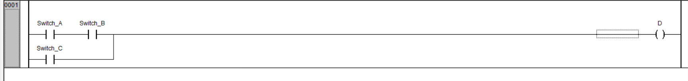

Ladder diagram Running Condition:
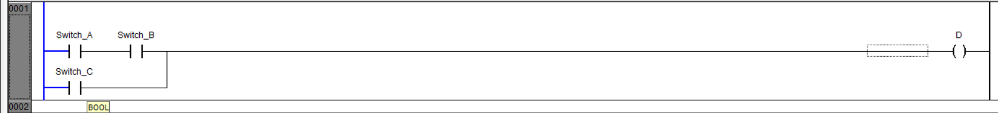

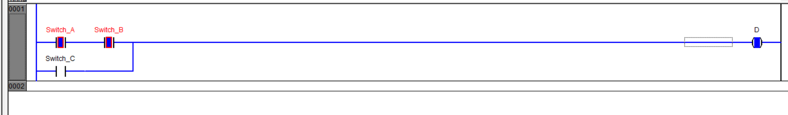

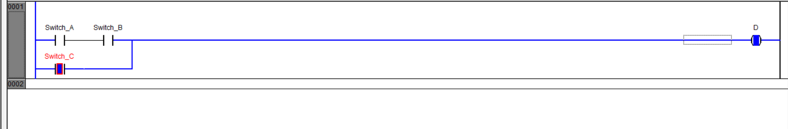

Q.6) Develop a program that will cause output D to be on when push button A is on, or Either B or B are on.

Ladder Diagram Initial Condition:

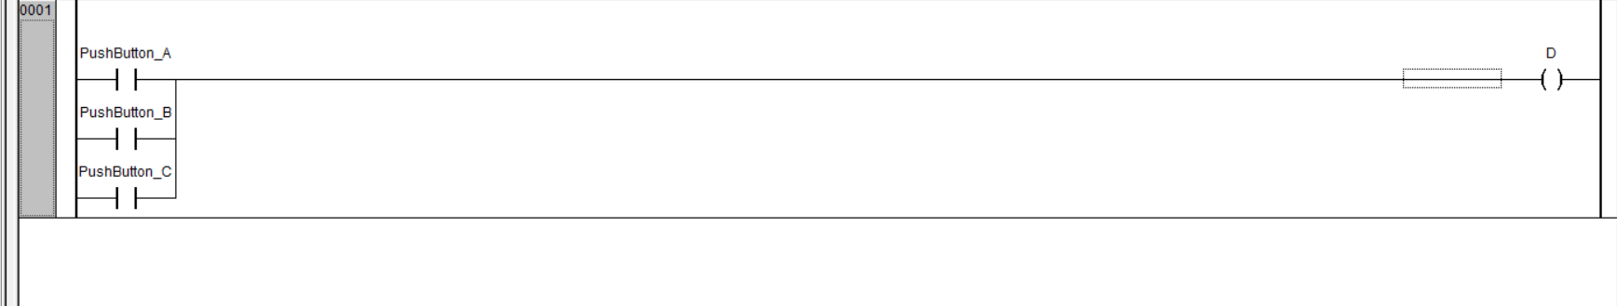

Ladder diagram Running Condition:
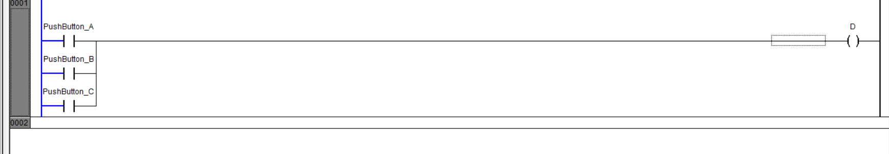

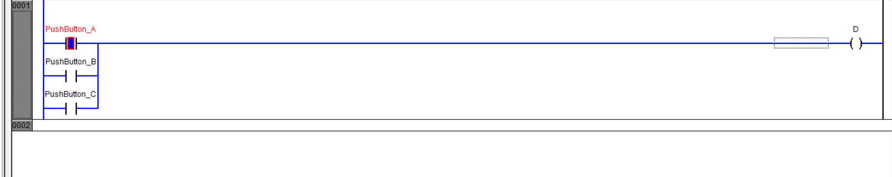

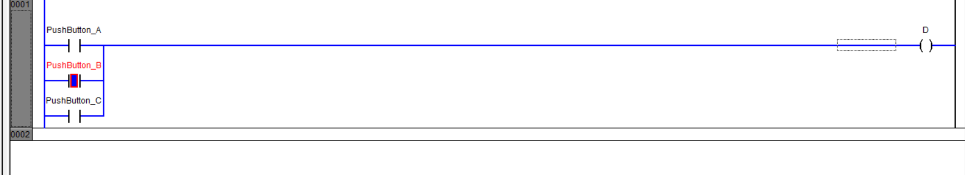

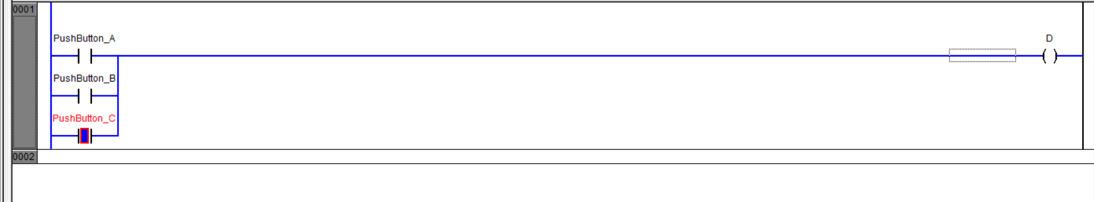

Q.7) Draw a ladder diagram and digital logic diagram for following applications?
Y is on when (A is on, B is on and C is off ) or D is on, or E is off.

Y = ABC+D+E

Ladder Diagram Initial Condition:

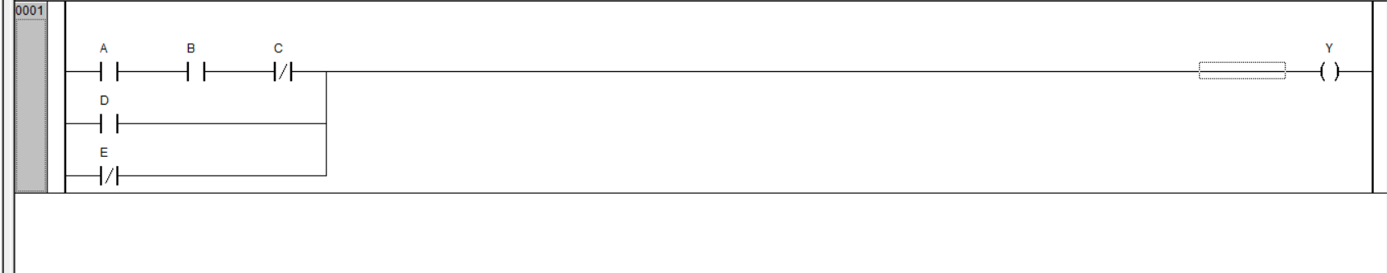

Ladder diagram Running Condition:
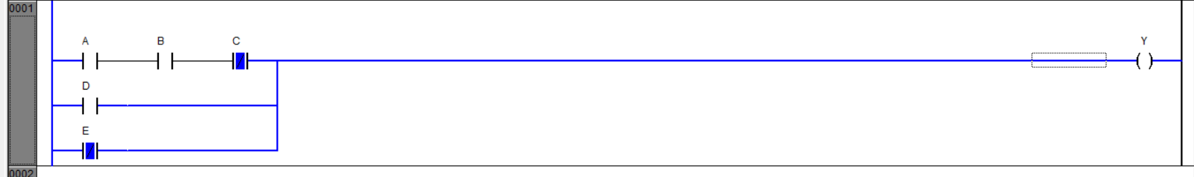

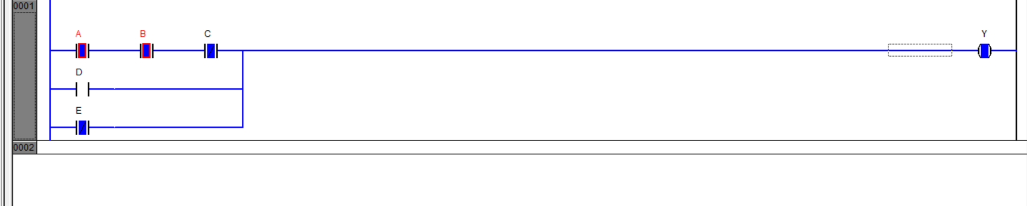

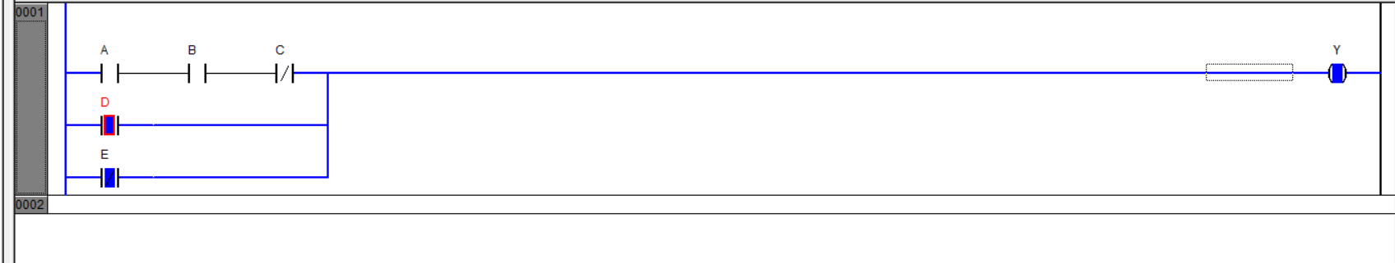

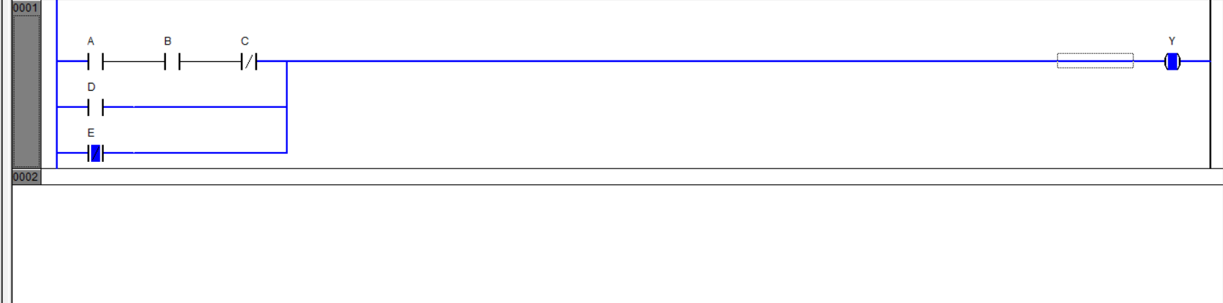

Q.8) A Fan is to be started and stopped from three different locations. Each location has start and stop push buttons.

Ladder Diagram Initial Condition:

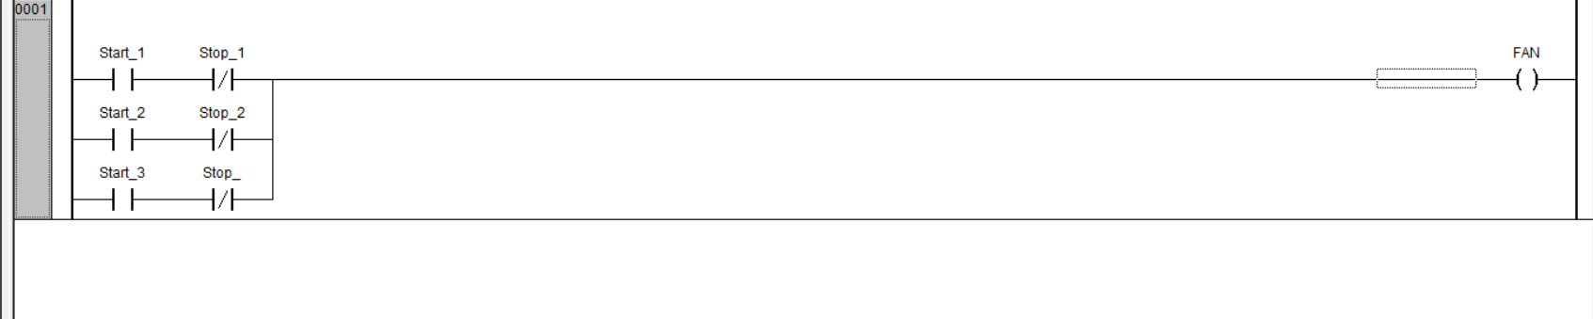

Ladder diagram Running Condition:

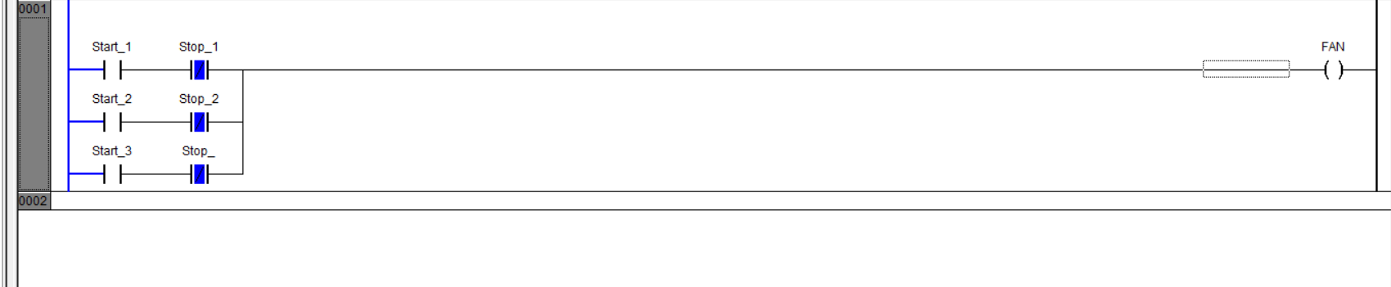

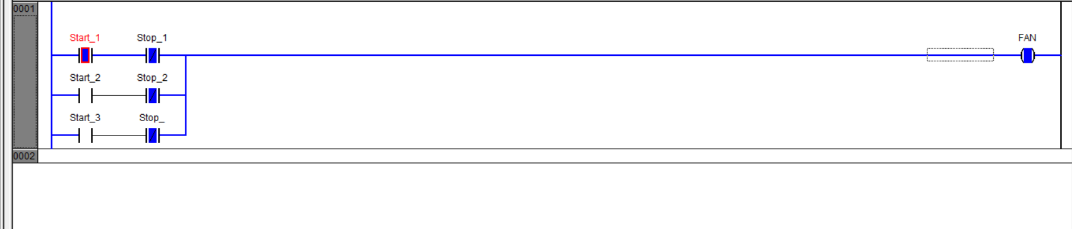
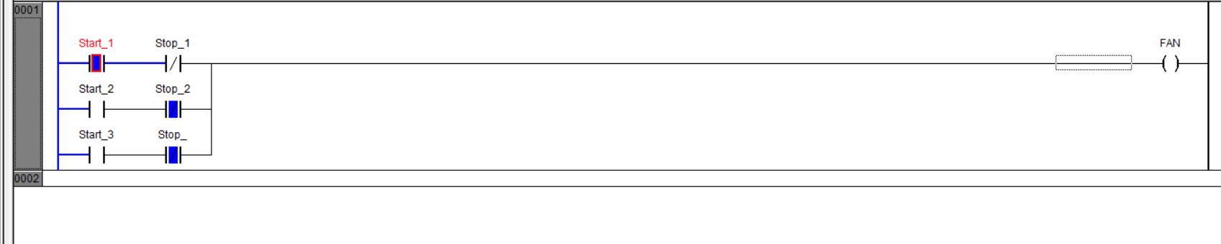

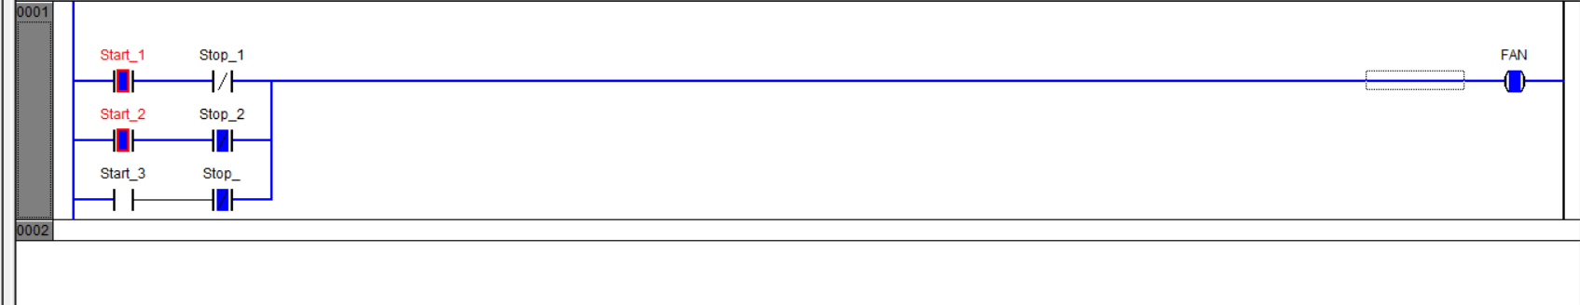

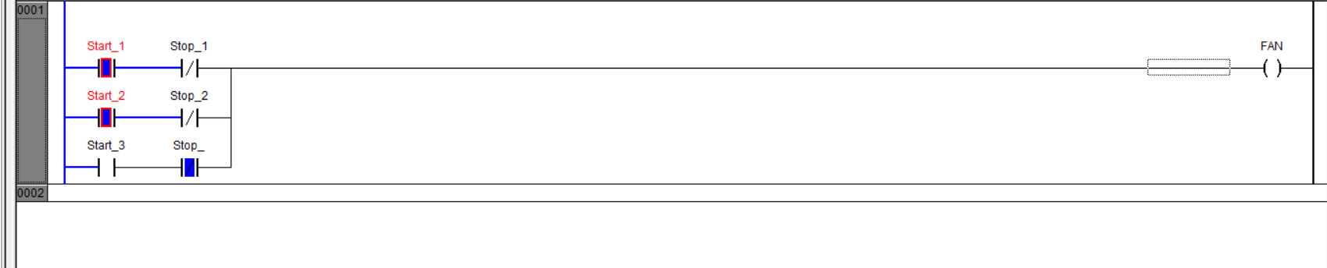

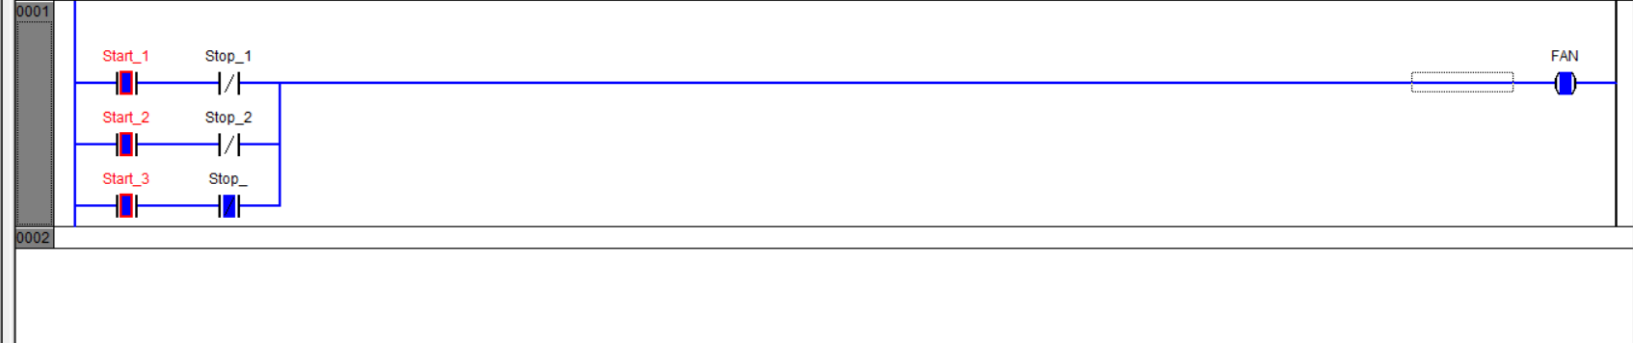

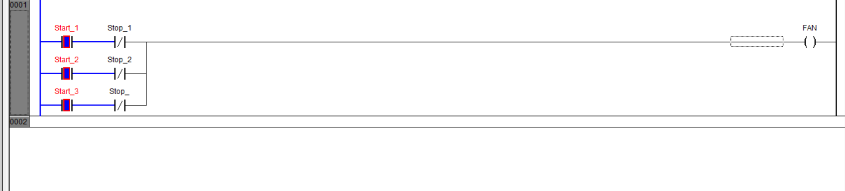

Q.9.1) Draw the ladder diagram for the following function table.

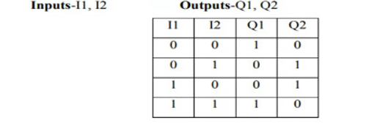
Ladder Diagram Initial Condition:

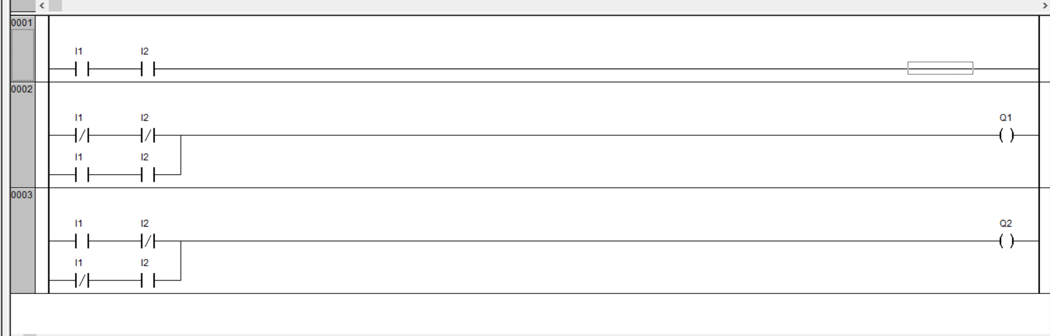

Ladder diagram Running Condition:

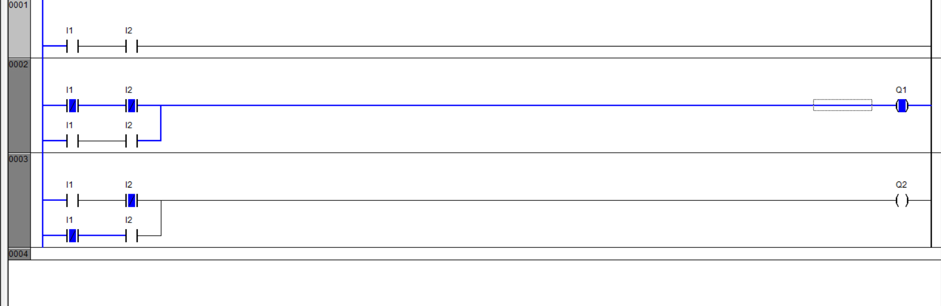

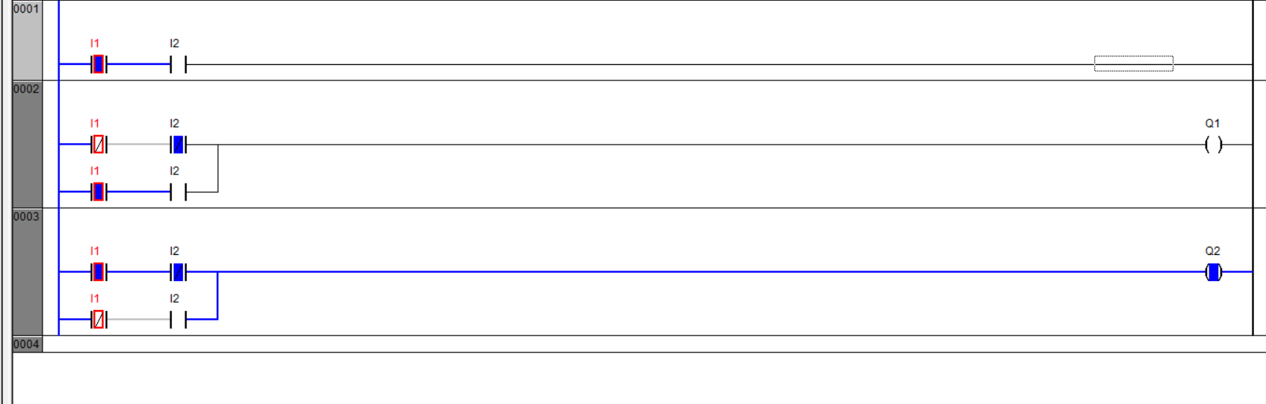

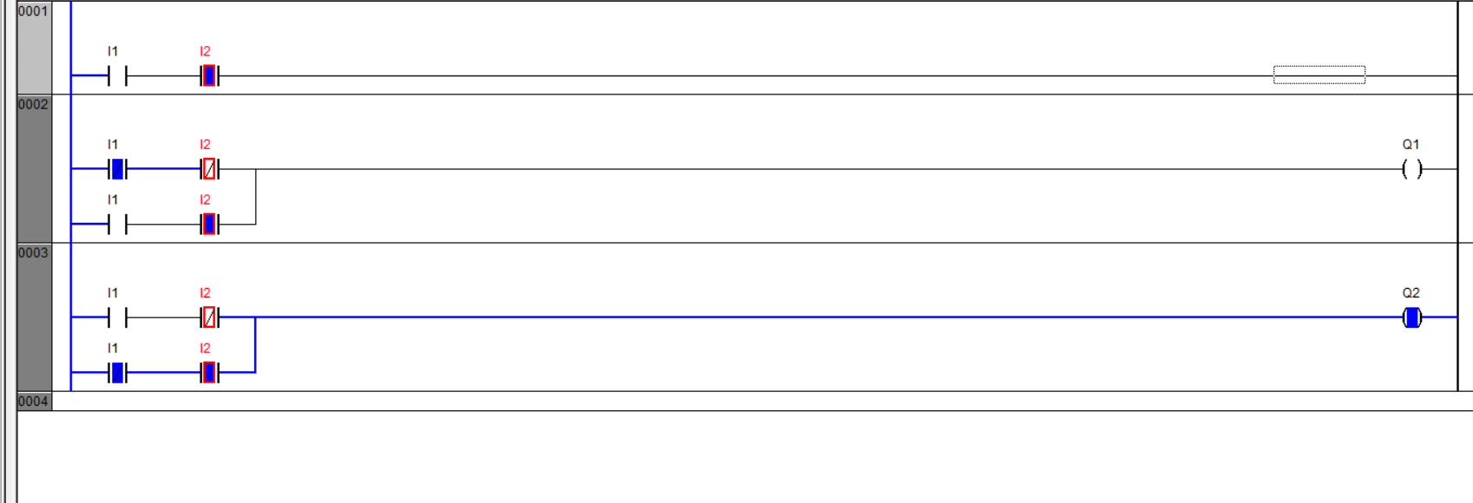

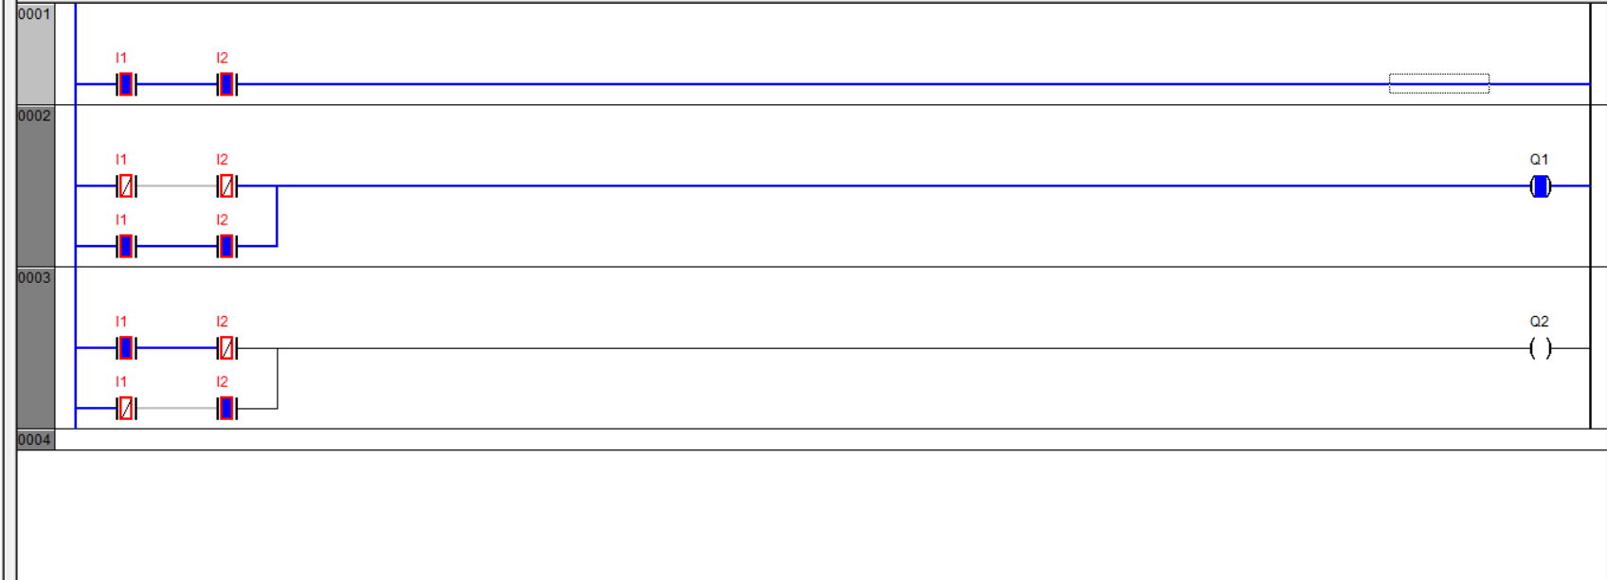

Q.9.2) Draw the ladder diagram for the following function table.

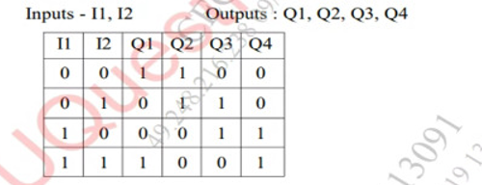

Ladder Diagram Initial Condition:
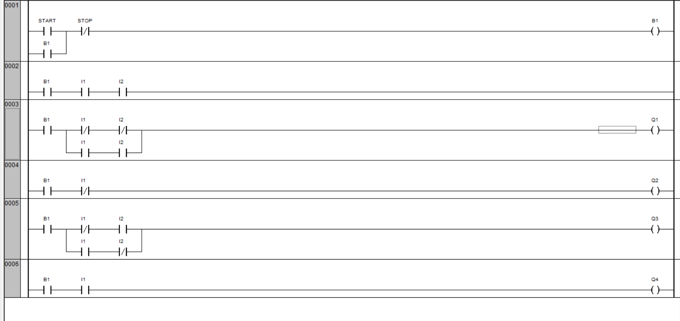

Ladder diagram Running Condition:

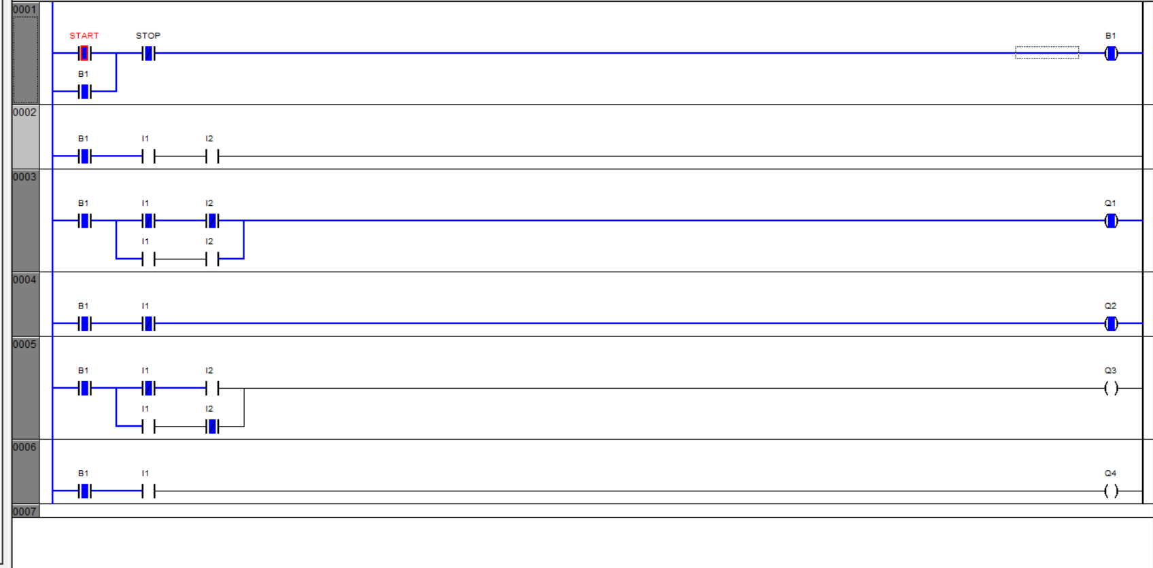

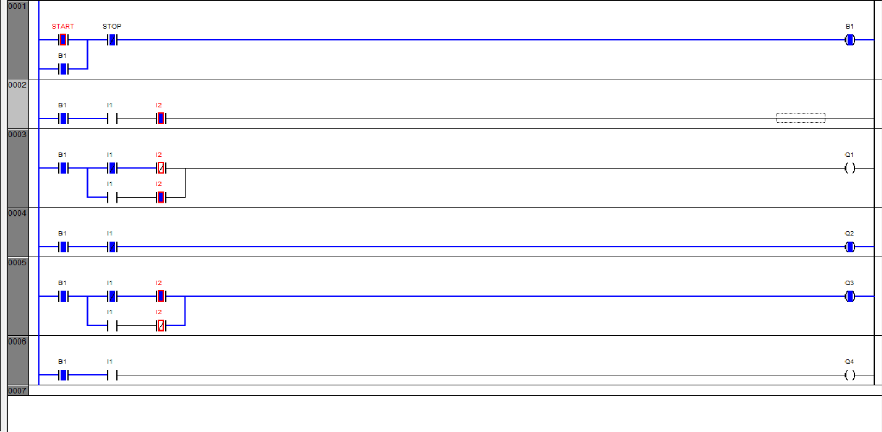

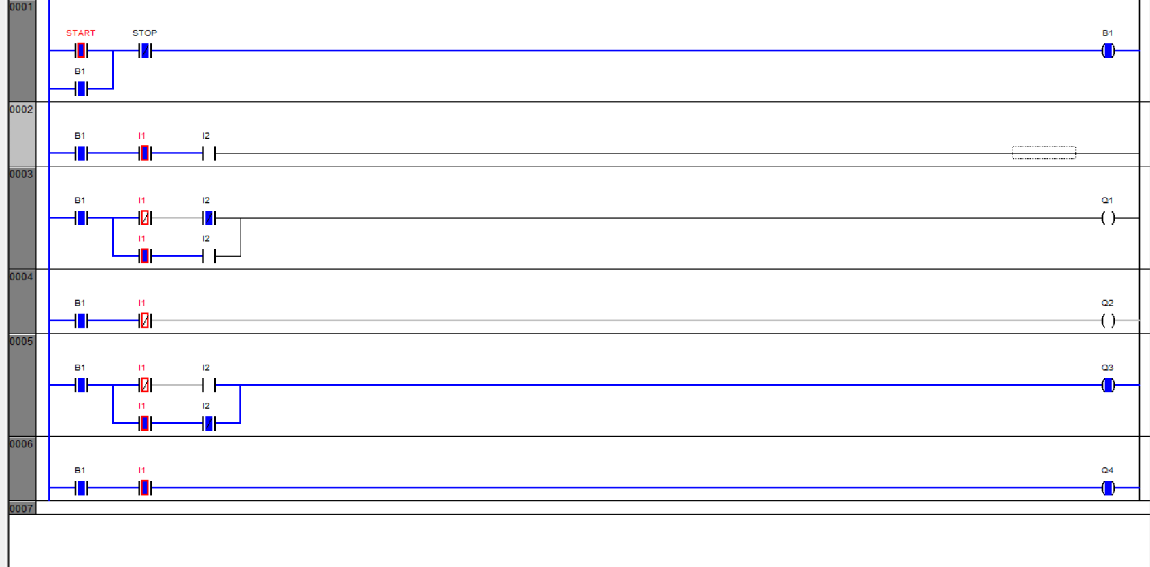

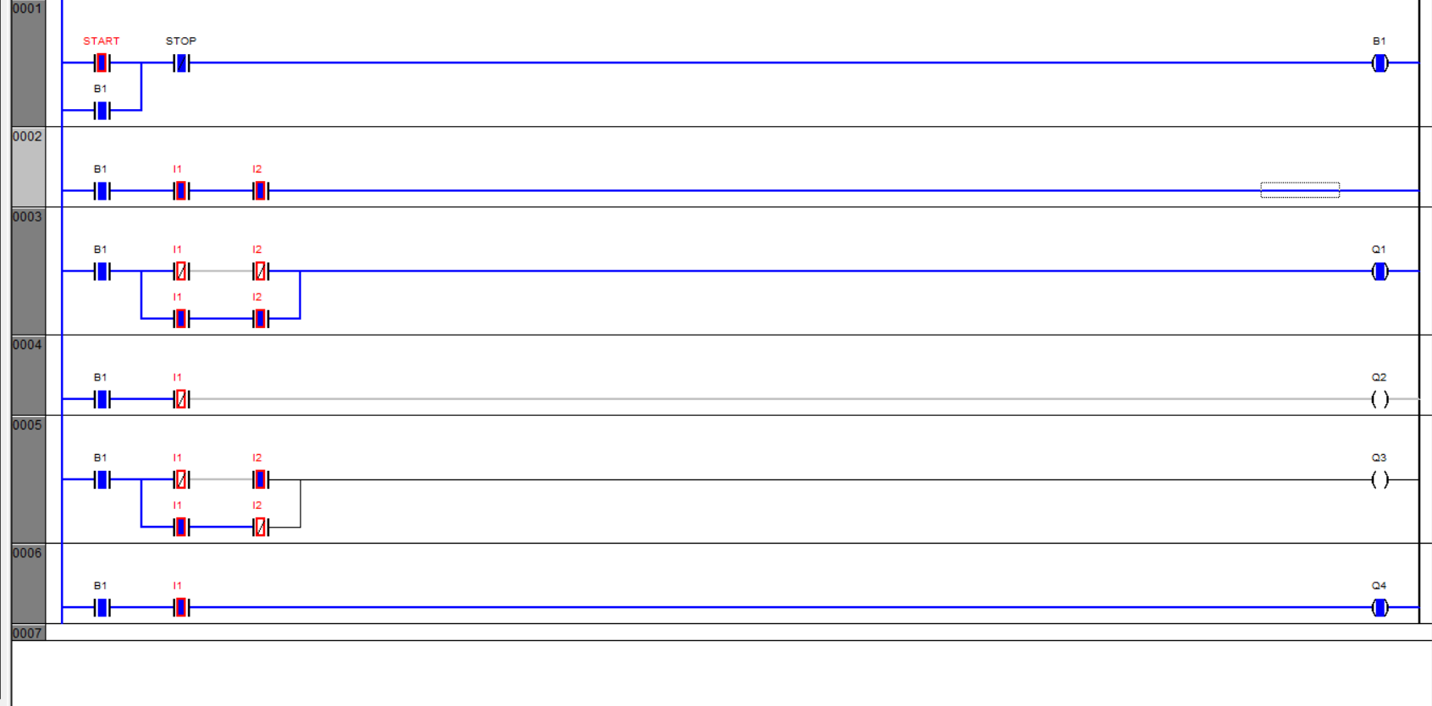

Q.10) There are two buttons and three lamps
- When PB1 Pressed then only blue and green lamp on.
- When PB1 and PB2 Pressed simultaneously then only Red lamp on.
- When PB2 Pressed then only green lamp on.

Ladder Diagram Initial Condition:

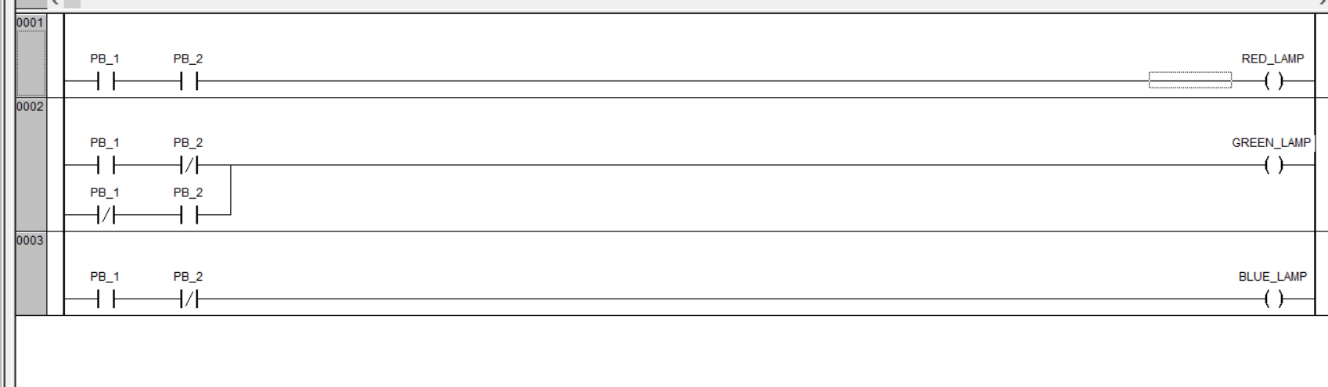

Ladder diagram Running Condition:
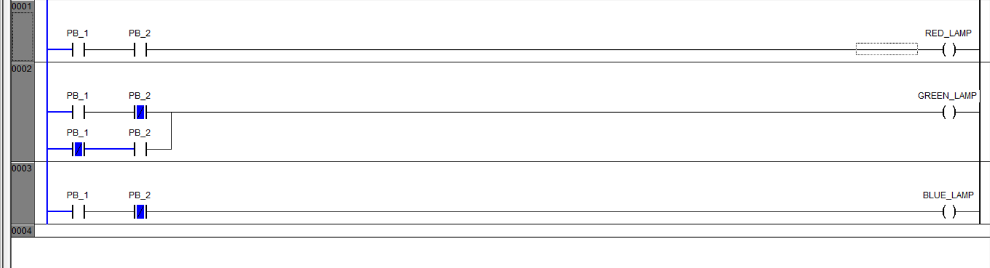

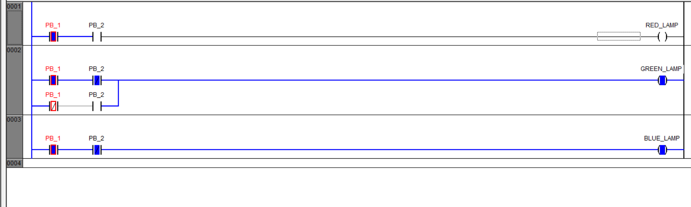

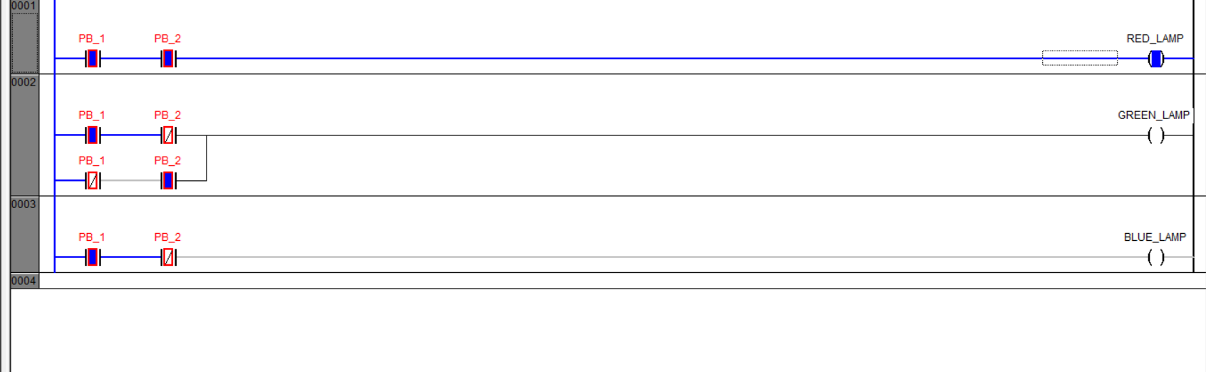

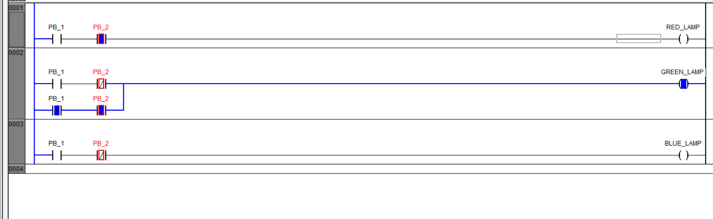

Conclusion:
- We learnt about Ladder Diagram Programming for PLC.
- We have completed different on-off applications using the Ladder Diagram.
- We have implemented Logic Gates using Ladder Diagram.

